navcenter@salemstate.edu
Phone: 978.542.8000
Fax: 978.542.8520
Student Navigation Center

How to: Make a Payment on My Payment Plan
- Log into Navigator.
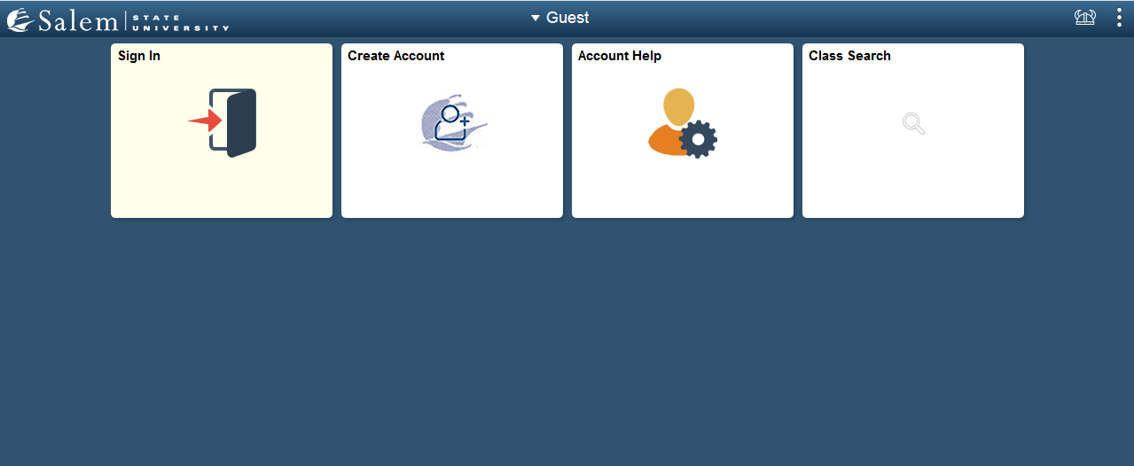

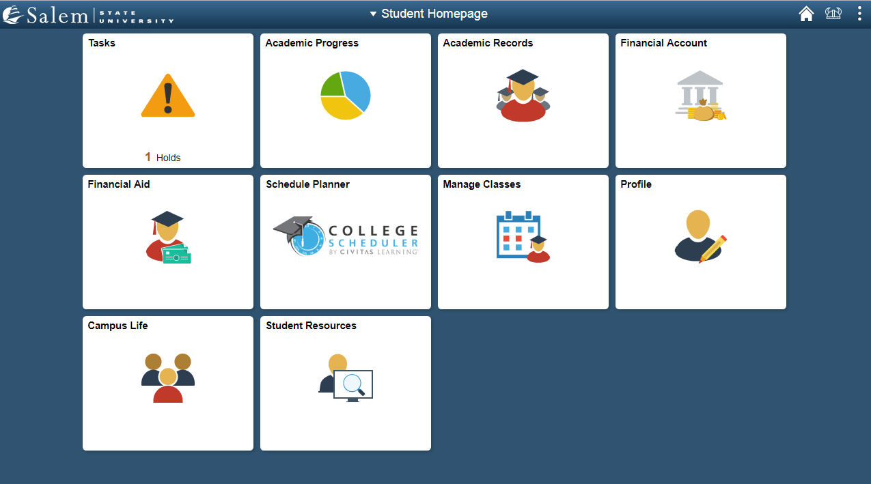
- Once at the Student Homepage, click on “Financial Account”.

- On the menu bar, click on “ Student Accounts”. Then follow the “Click Here” link to access TouchNet.
Note: Please make sure that pop-up windows are enabled.

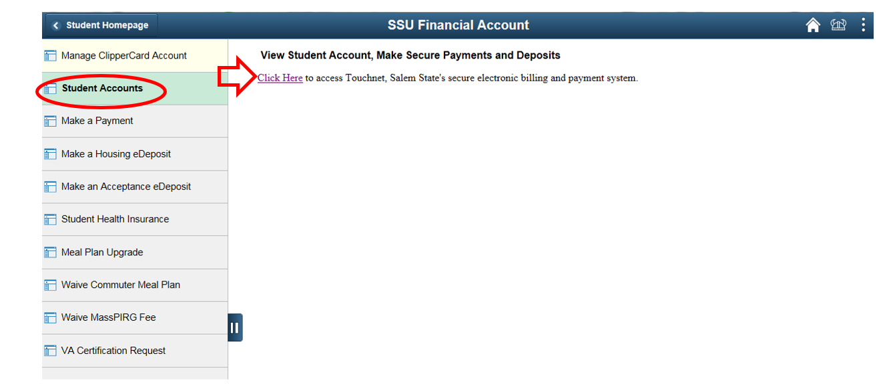

- In the menu-bar at the top of the page, click on "Payment Plans".
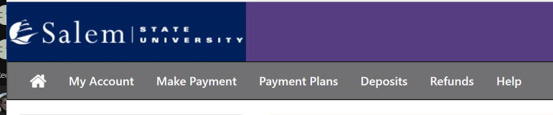

- The page will default to the "Manage Plans" tab located under the heading "Payment Plans". Here, you be able to make individual payments or schedule payments.
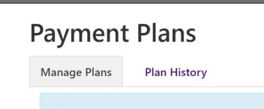
- To pay or schedule a payment, click on the gear button. To make a payment that is less than the amount showing, on the next screen, you will have the chance to change the amount. If scheduling a payment, please make sure that you have already set up your payment profile from My Profile.
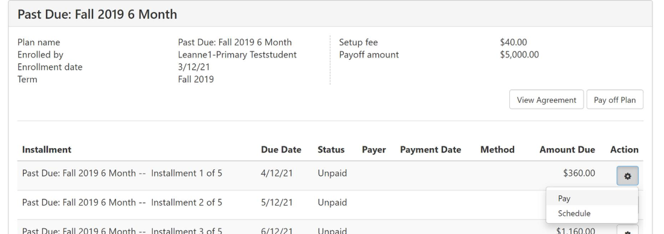

NOTE: We accept all major credit cards. A 2.95% non-refundable service fee ($3 minimum fee) for domestic credit cards and 4.25% non-refundable service fee for international credit cards, will be assessed by our credit/debit card processor for credit/debit card payments.
- You can now pay your payment plan in full if you wish. Click on the green Pay Off Plan button. This will complete your payment plan and bring your balance to 0.00.
